LESSON 1: OVERVIEW OF THE INTERNET AND THE WEB

INTERNET-BASED SERVICES
Some of the basic services available to Internet users are −
- Email − A fast, easy, and inexpensive way to communicate with other Internet users around the world.
- Telnet − Allows a user to log into a remote computer as though it were a local system.
- FTP − Allows a user to transfer virtually every kind of file that can be stored on a computer from one Internet-connected computer to another.
- UseNet news − A distributed bulletin board that offers a combination news and discussion service on thousands of topics.
- World Wide Web (WWW) − A hypertext interface to Internet information resources.
INTRODUCTION TO THE WORLD WIDE WEB
The official description of the World-Wide Web (WWW, W3) is a "wide-area hypermedia information retrieval initiative aiming to give universal access to a large universe of documents". It is a way of viewing all the on-line information available on the Internet as a seamless, browsable set of data.
The word "Web" refers to the combination of accessible objects and the links pointing to them throughout the Internet.
The Web is the worldwide collection of text pages, digital photographs, music files, videos, and animations you can access over the Internet. What makes the Web so special (and, indeed, gives it its name) is the way all this information is connected together. The basic building blocks of the Web are pages of text. A collection of Web pages on the same computer is called a website. Every web page (including this one) has highlighted phrases called links (or hypertext links) all over it. Clicking one of these takes you to another page on this website or another website entirely.
Computers connected to the web are called clients and servers based on a basic WWW model as shown:
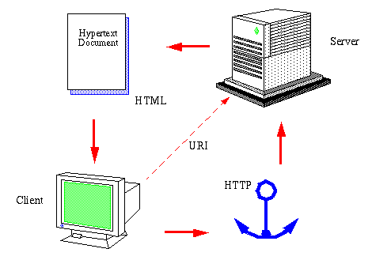

- Clients are the typical web user's internet-connected devices (for example, your computer connected to your Wi-Fi, or your phone connected to your mobile network) and web-accessing software available on those devices (usually a web browser like Firefox or Chrome).
- Servers are computers that store webpages, sites, or apps. When a client device wants to access a webpage, a copy of the webpage is downloaded from the server onto the client machine to be displayed in the user's web browser.
However there is a push to move from the limited client model with data flowing only from the server to the client, to the client is capable of posting data to the server if the server allows this kind of service as shown:
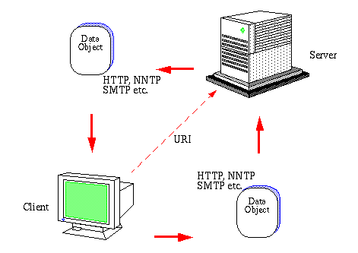

BASIC CONCEPTS IN THE WORLD WIDE WEB
- URL
URL stands for Uniform Resource Locator, and is used to specify addresses on the World Wide Web. A URL is the fundamental network identification for any resource connected to the web (e.g., hypertext pages, images, and sound files).
A URL will have the following format −
protocol://hostname/other_information
The protocol specifies how information is transferred from a link. The protocol used for web resources is HyperText Transfer Protocol (HTTP). Other protocols compatible with most web browsers include FTP, telnet, newsgroups, and Gopher.
The protocol is followed by a colon, two slashes, and then the domain name. The domain name is the computer on which the resource is located.
Links to particular files or subdirectories may be further specified after the domain name. The directory names are separated by single forward slashes.
- The http:// means the computer can pull this page off another computer using the standard process and protocol called HTTP. If the URL begins with https, it means the communication is encrypted as it travels between the browser in use and the Web server
- www.mu.ac.ke.com is the address or domain name of my computer. Some websites use domain names that begin with things other than www (for example maps.google.com and mail.yahoo.com), which are called subdomains. maps.google.com, drive.google.com, and indeed www.google.com are all subdomains of the main google.com domain.
- mypage.html is the name of the file you're currently reading off my computer.
- The .html part of the filename tells your computer it's an HTML file.
- Web Server
The server is responsible for handling the request sent from the client. This can either be a local accessible resource or the server can request the resource from another server in which case the first server temporarily turns into a client.
Every Website sits on a computer known as a Web server. This server is always connected to the internet. Every Web server that is connected to the Internet is given a unique address made up of a series of four numbers between 0 and 256 separated by periods. For example, 68.178.157.132 or 68.122.35.127.
- Hypertext Transfer Protocol
This is the protocol being used to transfer hypertext documents that makes the World Wide Web possible. The client sends of the user request to a WWW server using the Hypertext Transfer Protocol (HTTP). This is a typical client-server application based on a stateless connection between the client requesting the URI and the server handling the request.
- Website
This refers to a collection of various pages written in HTML markup language. Each page available on the website is called a web page and first page of any website is called home page for that site.
- Web Browser
Web Browsers are software installed on a user’s computer PC that allows the user to access the Web. Examples include: Netscape Navigator, Microsoft Internet Explorer or Mozilla Firefox. The process of navigating through pages of information on the web this is commonly known as browsing or surfing.
Faced with the dilemma of varying browser capabilities, web designers have developed a variety of design approaches, some more extreme than others. The "correct" way to handle a particular site, of course, depends on its use and audience, but this section should provide a peek into the different positions in the ongoing debate over where to draw the line.

Lowest Common Denominator Design:
One way to make sure your pages are accessible to everyone is to stick with the safest HTML standard (such as HTML 3.2) and shun any extras. That way your pages are sure to work on all browsers, including Lynx and Version 2.0 of the popular browsers.
A minority of web developers take the position that the current embellishments to HTML (Java, JavaScript, DHTML, and plug-in technologies like Flash) are unnecessary to successful communication over the Web. Designers who design for the lowest common denominator may choose not to use any of these technologies in their designs. This approach reflects the conservative extreme of the range of web design strategies.

Current Version Design
Another minority, at the other end of the spectrum, are the web developers who design only for the most current version of popular browsers (as of this writing, Netscape 6.0 and Internet Explorer 5.5), with little concern for site performance for other users. The statement "Tell them to upgrade -- it's free !" has often been used in defense of this design tactic. Beyond this, there are even designers who design for only the most current version of one particular browser or platform. This may be perfectly appropriate for intranet design in organizations that have standardized on a particular version of a single browser, but in general, it's unrealistic.
This approach has the obvious disadvantage of alienating a significant percentage of the audience. If the functionality of a site depends on a specific trick -- for example, if you can't get off the front page without DHTML support -- then your site has problems communicating. On the positive side, these designers tend to be the ones who forge new territories and put new technologies to the test. Creating exciting sites that depend on cutting-edge features does create an incentive for users to keep themselves up-to-date. Unfortunately, in many cases, upgrading is out of the control of the end user.

Splitting the Difference
Far more commonly, designers take a more balanced approach to web site creation. Designing web pages that "degrade gracefully" is the buzz phrase in web design circles. This design incorporates cutting-edge web technologies, such as DHTML or JavaScript, but implements them in such a way that the pages are still fully functional on older browsers.
One strategy is to design pages that take advantage of technology supported in the previous version of major browsers. As of this writing, that would be the Version 4.0 browsers. So, tables, frames, and much of JavaScript are fine, but DHTML effects may still be a problem.
The trick is to code your page such that it degrades well for older or more simple browsers. Simply being careful about always adding alternative text for images with the ALT attribute will make a web page more functional for Lynx users. When tables are used, they can be constructed so they read logically when scanned by a text-only browser.
Once working pages are developed using Version 4.0 technologies (while keeping an eye on performance on older browsers), the site can be embellished using the latest techniques and tricks. For instance, it is possible to create a page that looks just fine for all browsers but also takes advantage of Cascading Style Sheets for those browsers that can use them. It doesn't hurt the other browsers; the up-to-date users just get something extra. The same goes for DHTML tricks. They're fine as long as they're not used to carry the crucial message or functionality of the site. Think of these things as icing on the cake.
By being mindful of how well elements degrade, you can construct pages that wow 'em on the current browsers but don't drive users away if they're using an earlier version.

Something for Everyone
An approach that is common (albeit more labor-intensive) among professional web developers is to create multiple versions of a site aimed at different levels of users. One site might incorporate DHTML tricks and JavaScript events. Another could be a solid HTML 3.2-compliant site with images and attractive page layouts, but without the bells and whistles. You could create a text-only version to serve the folks using Lynx, nonvisual browsers, and browsers on handheld electronic devices. If you were feeling ambitious, you could provide an all-Flash version of your site for those who are interested. In most cases, two carefully planned versions are plenty: one that takes advantage of the full functionality of the latest graphical browser and another stripped-down version that serves everyone else.
Some sites allow their users to decide which version they'd like to see. It's not uncommon to arrive at a site and be asked to choose between a souped-up version or a text-only version, or to choose frames/no-frames or Flash/no Flash. This puts the control in the hands of the viewer.
A more sophisticated approach is to automatically serve up an appropriate version of the page for the browser that is making the request. JavaScript is capable of performing actions based on the browser being used (see Chapter 28, "Introduction to JavaScript"). Pages can also be assembled on the fly for a particular browser using Server Side Includes (see Chapter 18, "Server Side Includes"). Hotwired's WebMonkey site is a great example of this method in action, plus they share their secrets, so check it out at http://www.webmonkey.com.
Of course, this approach takes a bit more time and technical know-how, but it has its rewards.

Take Advantage of Tools
Whether you are designing with particular browsers in mind or with the goal of reaching the widest browser audience possible, the good news is that there are tools that can help you. The latest web authoring tools, such as Macromedia Dreamweaver and Adobe GoLive, have functions that ensure that your code will work with your preferred browsers. They give you a good head start toward creating HTML properly for your intended audience.
Dreamweaver 4.0 has a "Check Target Browser" feature that checks your HTML (but, unfortunately, not scripts) against a list of browser profiles to see if any tags or attributes are unsupported and then generates a report with its findings. Go to Macromedia's site (http://www.macromedia.com) to download browser profile updates as new browsers are released. To take some of the guesswork out of browser support for scripting, Dreamweaver allows you to set a target browser, to which it responds by limiting the behaviors you can select to just those supported in that browser. There are also built-in functions for doing browser detection.
Similarly, Adobe GoLive lets you define a set of browsers you want to support and automatically lets you know if it finds HTML tags or attributes that are not supported. Select the set of browsers you want to support using the Browser Sets option under the Source category in the Preferences dialog box. In fact, GoLive has a Web Database feature that lists all the HTML tags and their browser-support information. You can also select a target browser when adding scripts to your page and use the Browser Switch icon to detect the browser version and serve the appropriate script.
HOW THE WEB WORKS
The moment a user enters an address in the browser and you hit ENTER, a lot of different things happen: 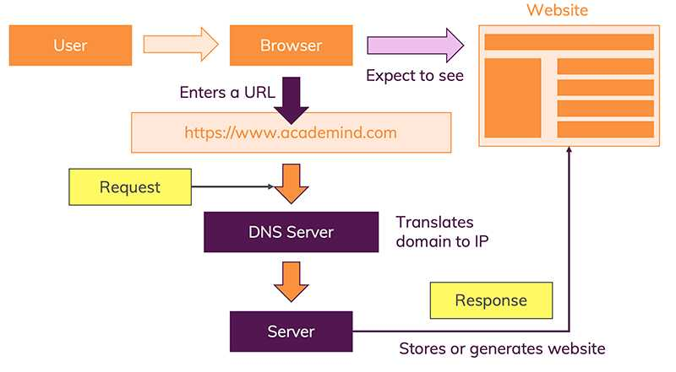
- The URL gets resolved:
The browser goes to the DNS server, and finds the real address of the server that the website lives on. The server which hosts the source code of a website, is identified via IP (= Internet Protocol) addresses. When a URL is entered such as www.mu.ac.ke it is resolved by being translated into an IP .e.g. 192.175.2.1. This is done by the Domain Name Servers, a server that contains a database of public IP addresses and their associated hostnames, and in most cases serves to resolve, or translate, those names to IP addresses as requested. DNS servers run special software and communicate with each other using special protocols.
- A Request is sent to the server of the website:
With the IP address resolved, the browser goes ahead and makes a request to the server with that IP address. The browser sends an HTTP request message to the server, asking it to send a copy of the website to the client (you go to the shop and order your goods). This message, and all other data sent between the client and the server, is sent across your internet connection using TCP/IP.
General Request example:
Request URL: www.mu.ac.ke
Request method: GET
Remote address: example 192.168.1.2
Status code: 200 OK
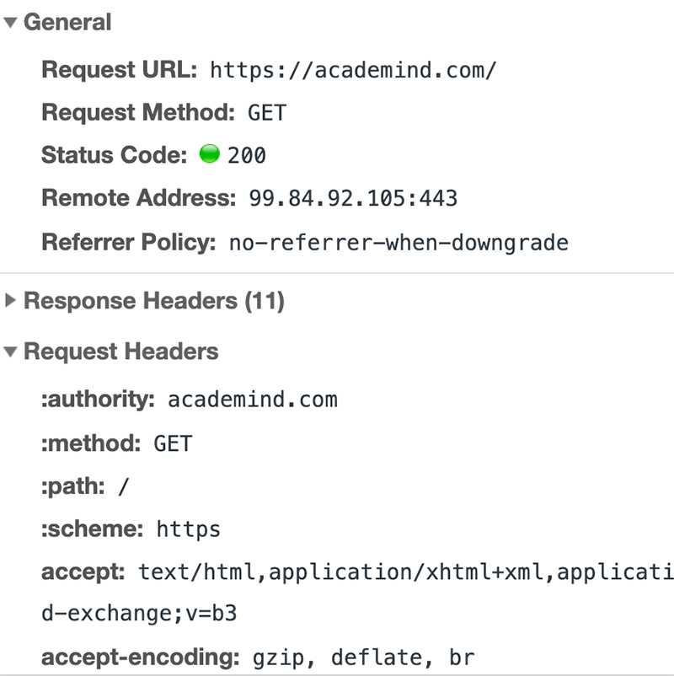
If the server approves the client's request, the server sends the client a "200 OK" message, which means the page can be viewed by the client.
- The response of the server is parsed
The next step is that the browser parses the response. Just as the server did it with the request. Again, the standardization enforced by HTTP helps of course.
The browser checks the data and metadata that’s enclosed in the response. And based on that, it decides what to do.
You might’ve had cases where a PDF opened in your browser. That happened because the response informed the browser that the data is not a website but a PDF document instead. And the browser tries to pick the best handling mechanism for any data type it detects.
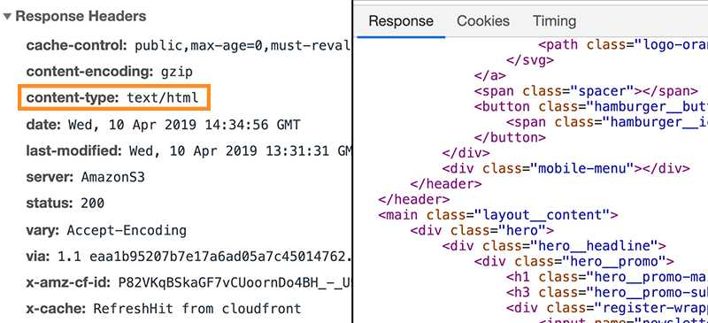
If the document is a HTML document each tag is understood and the content it carries
- The page is rendered and displayed
The browser assembles the small chunks into a complete website and displays it to you

